 | SIMATS ENGINEERING  Department of Computer Science and Engineering
CSA15 Cloud Computing and Big Data Analytics
CO4 AT3 - Big Data Reverse Engineering Task Workbook
Course Code | CSA15 | Slot | B
Assessment | CO4 AT3 | Bloom Level | BL4 - Analyze
Faculty | Dr C. Rajesh Babu | Employee ID | SSETSCS415
Mode | Individual guided reverse-engineering workbook | Submission | GitHub repository link through Google Classroom
End Evidence | Workbook + screenshots + diagrams + presentation | Marks | 30

Student Details
Student Name | K.Varshini | Register Number | 192472358
Class / Section | CSE-AI | Slot | B
Selected Platform | swiggy | Submission Date
GitHub Link | https://github.com/varshinvarma1010/CSA1512.git | Google Classroom Status | uploaded
Workbook Purpose
What this workbook does
This workbook guides students to reverse-engineer a real, known digital platform purely from observable behaviour — no source code or internal documentation — and infer its likely data pipeline, analytics approach, privacy/security risks and the business decisions that analytics probably drives.

• Do not claim access to private source code or internal documentation you do not actually have.
• Base every inference on observable evidence: app/website behaviour, published engineering blogs, app store listings, public API docs, news articles, the privacy policy.
• Screenshots and cited sources are evidence; your reasoning is the actual assessment answer.
• Being explicit about what you are confident about versus what you are guessing is part of the grade, not a weakness.

Platform Bank
Instruction
Faculty may assign one platform or allow student choice. If self-selecting, pick a platform you personally use and can observe closely (create test interactions, check settings and notifications, read the privacy policy) rather than one you only know by reputation.

No. | Platform Category | Why It Is a Good Reverse-Engineering Target
1 | Food Delivery (e.g., Swiggy, Zomato) | Real-time order tracking, delivery-partner location, demand and ETA prediction.
2 | Streaming (e.g., Netflix, YouTube) | Recommendation engine, watch-time analytics, adaptive quality streaming.
3 | Ride-Hailing (e.g., Ola, Uber) | Real-time GPS matching, surge pricing, ETA prediction.
4 | E-Commerce (e.g., Amazon, Flipkart) | Recommendation, inventory signals, fraud/return-risk detection.
5 | Social Media (e.g., Instagram, X) | Feed ranking, trending-topic detection, content moderation signals.

Selected Platform and Reason
Selected Platform: Swiggy – Food Delivery and Online Services Platform
Core Function:
Swiggy is an online food delivery platform that connects customers with restaurants and delivery partners. Users can search for restaurants and food items, view menus, add items to a cart, place orders, make payments and track the delivery status.
Why Swiggy is a Good Reverse-Engineering Target:
Swiggy is suitable for this task because it handles different types of data such as customer searches, restaurant and menu information, orders, delivery-partner locations, addresses and payment-related information. Some features such as order status and delivery tracking require fast data processing, while historical orders and customer behaviour can be analyzed later. This makes Swiggy useful for studying big-data concepts such as real-time processing, batch processing, data storage, analytics and security.
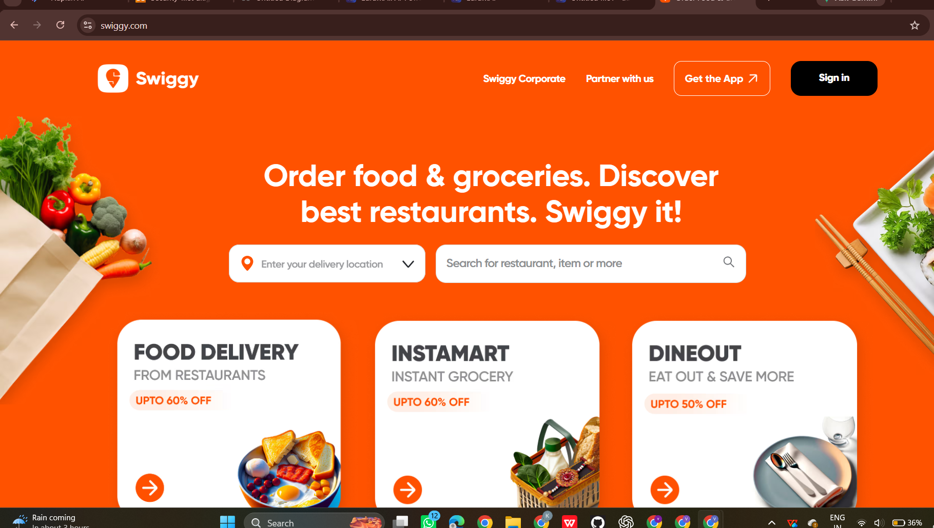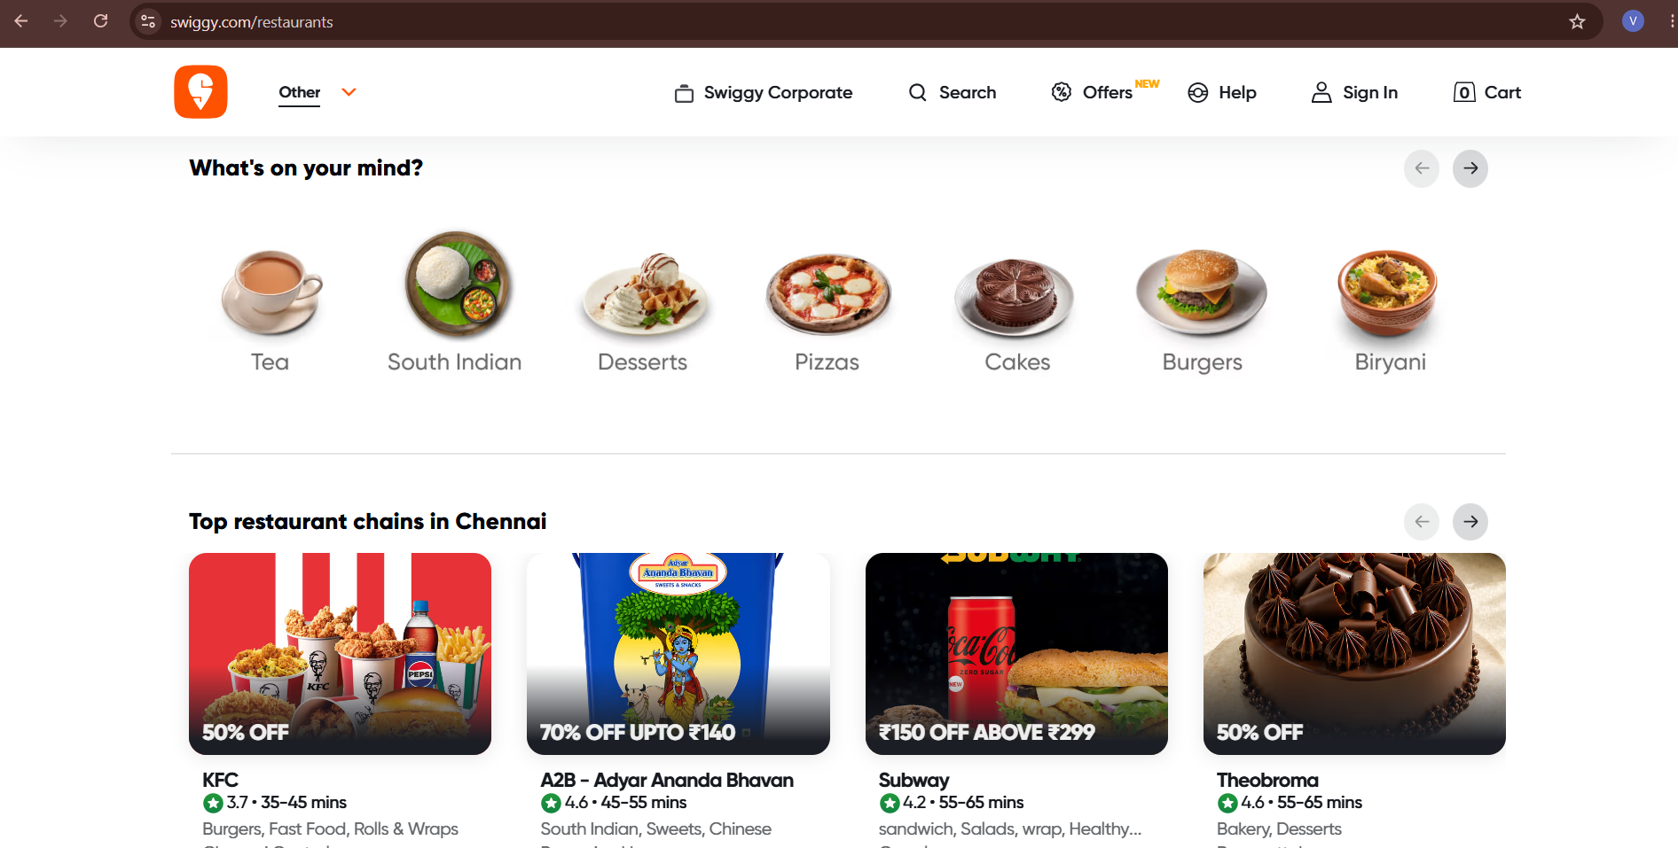

Guided Tool Module 1: Observe the Platform Directly (Behavioural Reconnaissance)
Purpose: Collect observable evidence of how the platform actually behaves under normal and edge-case use, before inferring any internal architecture. Follow every sub-step below in order.
Step 1.1: Open the Platform and Sign In
• Mobile app: open the Play Store (Android) or App Store (iPhone), search the exact platform name, tap Install if not already installed, then open it.
• Website: open any browser, type the exact web address, and press Enter.
• Log in, or create a free test account if you don't already have one. Never enter real payment card details for this exercise.

Student Note
Take one screenshot of the home/landing screen right now. This is your first evidence item — label it "01_home_screen".

Step 1.2: Perform 5 Common Actions and Time Each One
Purpose: Generate real, observable behaviour you can analyze in later steps.
• Action 1 — Search: use the search bar to look for something relevant (a dish, a movie, a destination, a product, or a hashtag depending on your platform).
• Action 2 — Open a detail page: tap/click into one result (a restaurant page, a video page, a ride option, a product page, or a post).
• Action 3 — Commit an action: add to cart, add to watchlist, select a ride, or follow an account.
• Action 4 — Trigger a notification-worthy event: start an order, start playback, request a ride, or like a post. Stop and cancel BEFORE any real payment step.
• Action 5 — Open Settings/Profile and note what fields exist (saved address, saved payment methods, notification preferences).
• For every action, use your phone/laptop clock (or say the seconds out loud and time yourself) from the moment you tap/click to the moment the screen fully updates.

Student Note
Fill one row of the "Observed Feature" table below for each of these 5 actions as you go — do not wait until the end to write them down from memory.

Step 1.3: Open Browser DevTools and Watch Data Requests (Website Only)
Purpose: See the platform's backend calls directly, instead of guessing.
• Right-click anywhere on the page and choose Inspect (or press F12 on Windows, or Cmd+Option+I on Mac).
• In the panel that opens, click the "Network" tab along the top.
• Click the "Fetch/XHR" filter button so only data requests show, not images or fonts.
• Tick "Preserve log" if visible, then refresh the page (F5) with the Network tab still open.
• Repeat Action 1 from Step 1.2 (search) while watching the Network panel — new rows will appear as you type or press Enter.
• Click on one new row. Read its "Name" (the endpoint being called) and its "Time" (how long it took).

Student Note
Never copy long token/key strings from the Headers tab. Only note the endpoint name pattern (for example "/api/search?q=...") and its response time in milliseconds.

Step 1.3 (App Alternative): If You Only Have a Mobile App, Use Loading-Time Evidence Instead
• Mobile apps don't show DevTools, so use what you can already see: which screens update the instant you tap something, and which show a spinner/loading animation first.
• Write in your notes: "Mobile app — network inspection not available; used on-screen loading-time evidence instead."

Step 1.4: Classify Each Feature as Real-Time or Delayed
• Go back through your 5 actions from Step 1.2, one at a time.
• Ask: did the change appear in under 1 second (Real-Time)? Did it take a few seconds but always arrive (Near-Real-Time)? Did it only appear after a refresh or a while (Delayed/Batch)?
• Write your answer for each action into the "Real-Time or Delayed" column of the table below.

Step 1.5: Search for the Platform's Official Engineering Blog
• Open a search engine and search exactly: "[platform name] engineering blog".
• Also search: "[platform name] how we built" and "[platform name] system design".
• Also check the platform's careers page (search "[platform name] careers") for a Tech Blog or Engineering link, and search YouTube for "[platform name] tech talk".
• If you find a genuine official source, write its exact title and paste the link.
• If nothing turns up after all three searches, write: "No official engineering source found after searching [search 1], [search 2], [search 3]." This is an acceptable, honest answer.

Step 1.6: Read the Privacy Policy and Permissions List
• On the app: open Settings, then look for About/Legal, then Privacy Policy.
• On the website: scroll to the very bottom of the homepage and click the "Privacy Policy" link in the footer.
• Press Ctrl+F (Windows) or Cmd+F (Mac) and type "collect" to jump straight to the data-collection section instead of reading the whole document.
• Note every data type mentioned: location, contacts, camera, device ID, payment info, browsing history, and so on.
• Also check phone-level permissions: Android — Settings > Apps > [App Name] > Permissions. iPhone — Settings > [App Name].

Student Note
Record every permission and data type you found directly in the Behavioural Evidence Log box below.

Observed Feature | Real-Time or Delayed | What This Suggests About Processing
Search for a restaurant or food item | Real-Time | Search requests need low-latency processing to return relevant results quickly.
Open a restaurant/menu page | Near-Real-Time | Restaurant and menu information is retrieved from backend storage and displayed quickly.
Add a food item to cart | Real-Time | Cart updates require immediate processing so that the current order state is maintained.
Start an order and view delivery status | Real-Time | Order events and delivery updates need continuous processing and quick communication with the user.

Behavioural Evidence Log
Platform: Swiggy
- Search: I searched for a food item/restaurant using the search bar. The results appeared quickly without requiring a manual page refresh. This suggests low-latency search processing.
- Restaurant/Menu: I opened a restaurant and viewed its menu. The restaurant details and available food items were loaded from the platform. This suggests retrieval from a backend database or service.
- Cart: I selected a food item and added it to the cart. The cart was updated immediately. This suggests real-time processing of cart and order-session information.
- Order/Tracking: I started the order process without completing a real payment. Order-related information and delivery status are designed to update quickly. This suggests streaming or event-based processing for order and delivery events.
- Profile/Settings: I opened the profile/settings section and observed account-related information such as personal details, addresses and preferences. This suggests retrieval of user data from stored account information.
Privacy/Data Observed:
The platform may handle information such as name, mobile number, email address, delivery address, location, order history, payment-related information, device information and notification preferences.
Note: Mobile app network inspection was not available, so on-screen loading-time behaviour was used as evidence.
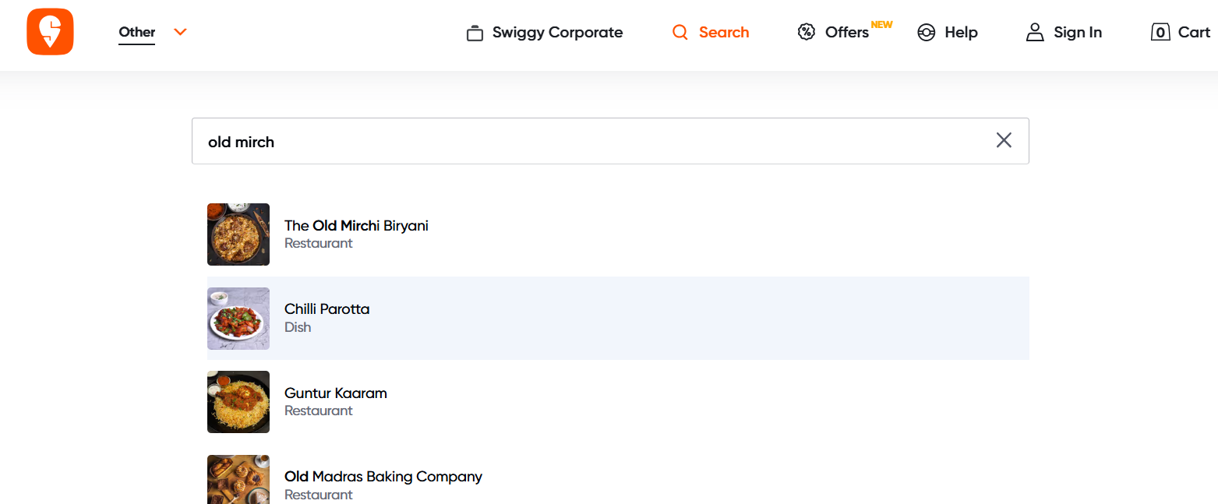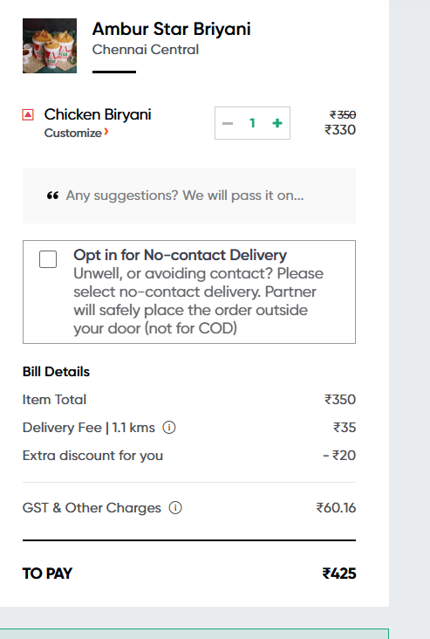

Guided Tool Module 2: Infer the Likely Architecture (Cloud Architecture Centers)
Purpose: Use the same official cloud architecture references as CO4 AT2 to infer which components this platform likely uses, based on its observed behaviour and any public information about its scale.
Step 2.1: Open the Three Official Architecture Centers
• Open three new browser tabs, one for each link below.
• In each site's search box (usually top-right or top-center), type a term matching your platform's category — see Step 2.2 for exact search terms.

AWS Architecture Center: https://aws.amazon.com/architecture/
Azure Architecture Center: https://learn.microsoft.com/en-us/azure/architecture/
Google Cloud Architecture: https://docs.cloud.google.com/architecture

Step 2.2: Search Using a Term That Matches Your Platform's Category
• Food delivery / e-commerce platform: search "e-commerce reference architecture" or "retail analytics architecture".
• Streaming platform: search "media streaming architecture" or "video on demand architecture".
• Ride-hailing platform: search "real-time location architecture" or "IoT reference architecture".
• Social media platform: search "social media analytics architecture" or "real-time data architecture".
• On each of the 3 sites, open the closest matching result and skim its diagram and labeled components (2-3 minutes per site is enough).

Student Note
Record the exact page title and URL from each of the 3 sites into the table below, even if the match is only partial — use whichever result is closest.

Step 2.3: Check for Public Tech-Stack Disclosure
• Open https://stackshare.io/ in a new tab. Use the search bar at the top and type your platform's exact name, then press Enter.
• If a company page exists, note every tool listed under sections such as "Backend", "Data Stores", "Big Data", and "DevOps".
• If no StackShare page exists, search instead: "[platform name] tech stack".
• Also search: "[platform name] careers backend engineer" — job postings often list required technologies (for example "experience with Kafka, Spark, AWS S3"), which is real, usable evidence.

Student Note
Record whatever you find. If nothing turns up after these three searches, write "not publicly disclosed" — that is a valid, honest finding.

Step 2.4: Draw Your Inferred Architecture in draw.io
• Open https://app.diagrams.net in a browser. Choose "Decide Later" (no account needed) when it asks where to save.
• Create 6 boxes left to right, in this exact order: Data Sources, Ingestion, Storage, Processing, Analytics/Dashboard, Users.
• In the "Data Sources" box, write the input types you observed in Module 1 (app taps, GPS pings, sensor data, images, and so on).
• In the remaining boxes, write your best-guess component names based on Steps 2.2-2.3 (for example: "likely a streaming ingestion service, similar to Kinesis/Kafka" if your platform showed real-time behaviour).
• Draw arrows connecting the 6 boxes left to right in order.
• Export the diagram: File > Export as > PNG, and save it to your computer.

Student Note
Paste the exported PNG into the "Inferred Architecture Diagram Evidence" box further below.

Step 2.5: Mark Confidence Levels
• Look back at your diagram's 6 boxes.
• Pick the ONE box you are most sure about (usually "Data Sources", since you observed it directly in Module 1) and write why in the table below.
• Pick the ONE box that is the biggest guess (usually the exact storage/processing technology name) and write why it is uncertain.

Inferred Component | Evidence Basis | Confidence
Customer/order/location data sources | Directly observed through app features and user interactions | High
API/event-based ingestion | Fast updates of search, cart and order-related information | Medium
Order and user databases | Persistent user/account/order information is required | High
Streaming/event processing | Live order and delivery-status behaviour | Medium-High

Inferred Architecture Diagram Evidence
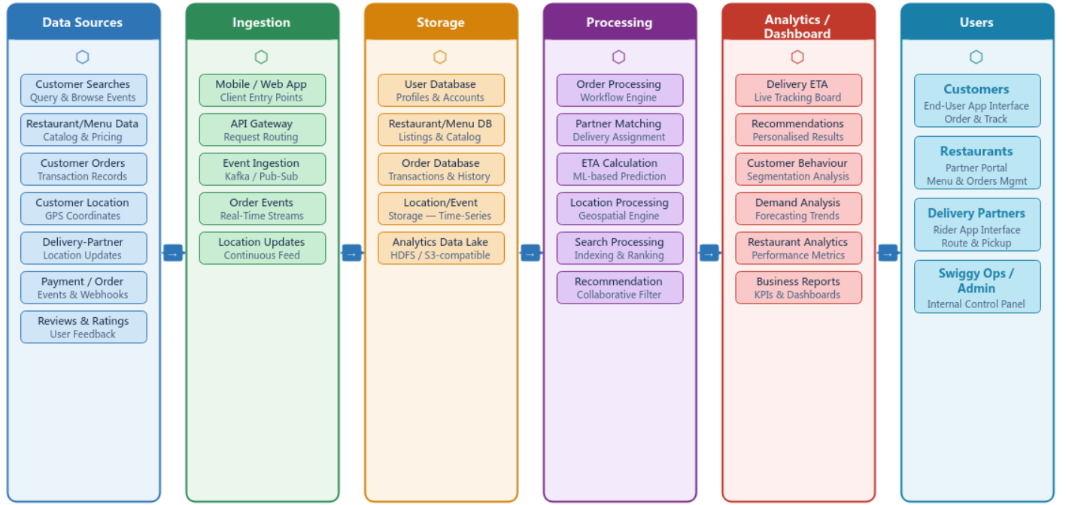

Guided Tool Module 3: Infer the Processing and Analytics Approach (Hadoop/Spark Documentation)
Purpose: Decide whether the platform's observed features most likely rely on batch, streaming, or hybrid processing, using the same Hadoop/Spark documentation used in CO4 AT2.
Step 3.1: Skim the Two Official Guides
• Open the Apache Hadoop MapReduce tutorial link below and read only the "Overview" section — the first 2 paragraphs are enough.
• Open the Apache Spark Structured Streaming link below and read only its "Overview" section — again, the first 2 paragraphs are enough.
• Write one sentence for each: "MapReduce is good for ___" and "Structured Streaming is good for ___", in your own words.

Hadoop MapReduce Tutorial:
https://hadoop.apache.org/docs/stable/hadoop-mapreduce-client/hadoop-mapreduce-client-core/MapReduceTutorial.html

Spark Structured Streaming Guide:
https://spark.apache.org/docs/latest/streaming/index.html

Step 3.2: Classify Every Feature From Module 1
• Open your Step 1.2 / Step 1.4 table again.
• Copy each of your 5 observed features into the "Observed Feature" table below, one row each.
• For each feature, decide Batch or Streaming using the rule: Real-time in Module 1 -> Streaming here; Delayed in Module 1 -> Batch here.
• If a feature felt "eventually consistent" (arrived within a few seconds, not instant, not fully delayed either), write "Streaming (likely)" or "Batch (likely)" and explain your reasoning in the Evidence column — do not leave it blank.

Step 3.3: Decide the Overall Pipeline Type
• Count how many of your 5 features you classified as Streaming versus Batch in Step 3.2.
• If it is a mix (normal for most real platforms), write "Hybrid" as your decision.
• Explain in one or two sentences: which features genuinely need streaming and why, and which features are fine running as batch and why.

Step 3.4: Write a Pseudo-Flow for One Feature
• Pick your single most confident Streaming or Batch feature from Step 3.2.
• Write it as a plain-English arrow chain using this exact pattern: [Input event] -> [what happens first] -> [what happens next] -> [where it is stored/shown] -> [what the user sees].
• Keep it to 4-6 arrows. Do not write real code — this is a plain-English flow, not a program.

Example (location ping):
GPS ping from phone -> streamed to ingestion service -> matched against route ->
ETA recalculated -> pushed to rider's app screen

Observed Feature | Batch or Streaming | Evidence / Reasoning
Restaurant/food search | Streaming | Results need to be returned quickly after the user searches.
Restaurant/menu display | Streaming (likely) | Information is retrieved quickly when the restaurant is opened.
Cart update | Streaming | Cart changes need to be reflected immediately.
Order/delivery status | Streaming | Delivery status and location can change continuously.

Processing Inference
Swiggy is likely to use a combination of streaming and batch processing. Streaming processing is important for order events, delivery-partner location updates, delivery status and ETA because these features require fast updates. Batch processing can be used for historical order analysis, customer behaviour analysis, restaurant performance reports and business analytics. Therefore, the overall processing approach is inferred as hybrid.

Pseudo-Flow for One Feature
Pseudo-Flow – Order and Delivery Tracking
Customer places order → Order request sent to backend → Order is processed and assigned → Delivery location/status events are received → ETA is recalculated → Updated status is displayed to the customer.

Guided Tool Module 4: Infer Privacy and Security Risks (Threat Modeling)
Tool Choice
Use OWASP Threat Dragon if you need a web/desktop cross-platform threat modeling tool. Use Microsoft Threat Modeling Tool when a Windows system is available. The required evidence is the threat model diagram and threat-control table.

Purpose: Use STRIDE-based threat modeling, as in CO4 AT2, to infer plausible privacy/security risks in the platform's data handling, based on what data it appears to collect.
Step 4.1: List Data Types With a Sensitivity Rating
• Go back to your Module 1, Step 1.6 privacy-policy findings.
• Copy each data type you found into the table below.
• Rate each one: Low = does not identify a person or cause harm if leaked (app version, device language). Medium = identifies a person but limited harm (name, email). High = could cause real harm if leaked (exact location, payment card, health data, biometrics).

Step 4.2: Open a Threat Modeling Tool and Create a New Model
• Web version (no install): go to the Threat Dragon link below and sign in with a free GitHub account if prompted, or use "Open Local Threat Model".
• Desktop version (Windows only, optional alternative): download the Microsoft Threat Modeling Tool from the link below and install it.
• Click "New Threat Model" / "Create Model".
• Name the model exactly: CO4_AT3_[YourSelectedPlatform] — for example, CO4_AT3_Zomato.

OWASP Threat Dragon:
https://owasp.org/www-project-threat-dragon/

Microsoft Threat Modeling Tool:
https://learn.microsoft.com/en-us/azure/security/develop/threat-modeling-tool-releases

Step 4.3: Build the Diagram
• From the left toolbar, drag an Actor (stick-figure icon) onto the canvas for each external entity you identified — at minimum the end user, plus one more (payment gateway, GPS provider, etc.).
• Drag a Process (circle icon) for each processing step from your Module 2 diagram (for example "Ingestion Service", "Analytics Engine").
• Drag a Data Store (parallel-lines icon) for each storage component (for example "User Database", "Event Log Storage").
• Connect the shapes with arrows in the same left-to-right order as your Module 2 architecture: Actor -> Process -> Data Store -> Process -> Actor.
• Use the toolbar's Trust Boundary line tool to mark any arrow that crosses from outside the company (the user's phone) to inside the company (the server).
• Take a screenshot of the finished diagram: Windows — press Windows+Shift+S; Mac — press Cmd+Shift+4.

Step 4.4: Generate and Answer Threats Using STRIDE
• Right-click each Process or Data Store shape and choose "Add Threat" (or open the Threats panel on the right side of the screen).
• The tool suggests STRIDE categories (Spoofing, Tampering, Repudiation, Information Disclosure, Denial of Service, Elevation of Privilege) per shape.
• For at least 3 of your components, open the suggested threats and pick ONE realistic threat per component — you do not need to answer every suggestion.
• In the Mitigation/Description box for each chosen threat, write a one-line description of the risk and its impact, then copy that same line into your workbook table below.

Step 4.5: Match Each Threat to a Real-World Control
• For each threat in your table, go back to the actual app/website and look for a visible trust signal: does it ask for a 2FA/OTP code at login? Does the address bar show a padlock/https? Does the privacy policy mention encryption?
• Write the matching control next to each threat.
• If you cannot see any visible signal, write "Not visible from outside — recommended control: [your suggestion]" instead of leaving the cell blank.

Component / Data Flow | Threat | Impact | Likely / Recommended Mitigation
User Login | Spoofing / Account Takeover | Unauthorized access to user account | OTP-based authentication, strong session management and login monitoring
Location Data | Information Disclosure | User's location could be exposed | Encryption, access control and minimum required data collection
Order Data | Tampering | Incorrect order or delivery information | Server-side validation and integrity checks
Payment Data | Information Disclosure | Financial information could be exposed | Encryption, secure payment gateway and tokenization

Threat Model Diagram Evidence
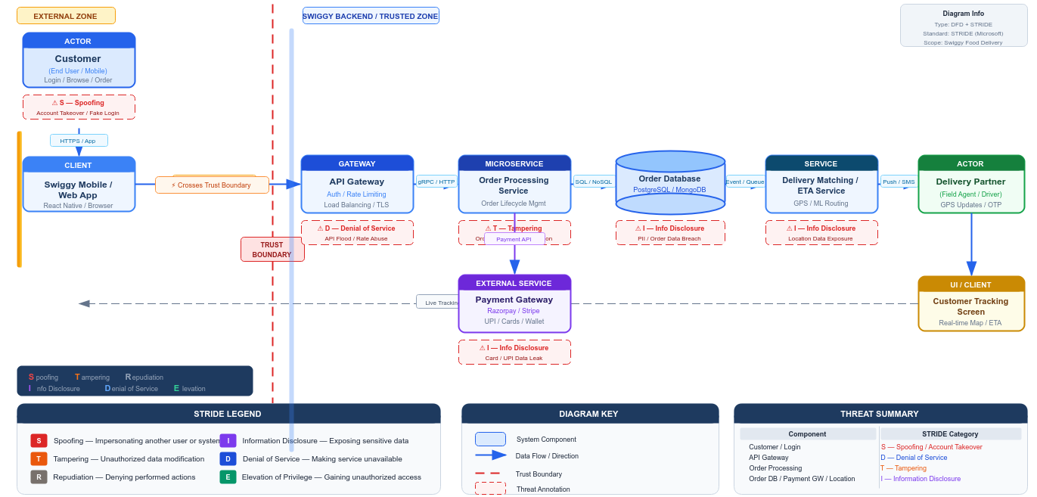

Final CO4 AT3 Solution Sections
Final Assembly
After completing the guided tool modules, combine the evidence into the final solution. The final answer must show technical reasoning and honest uncertainty, not only screenshots.

1. Platform Overview and Why It Was Selected
What to include: Identify the platform, its core users, its core function, and why it is a suitable reverse-engineering target.
Swiggy is a food delivery and online services platform used by customers, restaurants and delivery partners. Customers can search for restaurants and food items, view menus, add items to a cart, place orders and track deliveries. It is a suitable reverse-engineering target because the platform handles different types of data and includes features that require fast updates, especially order processing and delivery tracking. These observable behaviours provide useful evidence for inferring a big-data architecture and processing approach.

2. 5Vs Mapping (Inferred)
What to include: Map Volume, Velocity, Variety, Veracity and Value using the behavioural evidence gathered in Module 1.
Volume: Swiggy can generate large amounts of data from customer searches, restaurant information, orders, payments, ratings and delivery-location updates.
Velocity: Order events, delivery status and location information can change continuously, requiring fast processing and updates.
Variety: The platform handles different data types including text, user profiles, restaurant/menu information, location data, order records, ratings and transaction-related information.
Veracity: Data quality is important because incorrect addresses, locations, restaurant availability or order information can affect delivery and customer experience.
Value: The collected data can support faster delivery, better restaurant recommendations, demand analysis, improved customer experience and operational decision-making.

3. Inferred Data Pipeline and Architecture
What to include: Paste the final inferred draw.io architecture showing sources, ingestion, storage, processing, analytics/security and users.
The inferred Swiggy pipeline starts with data sources such as customer searches, orders, restaurant information, customer location and delivery-partner location. The data is likely received through application and API services and passed to appropriate storage systems. Processing services can then handle order management, delivery matching, ETA calculation, search and recommendations. Analytics can use both current and historical data for operational and business decisions.
Inferred flow:
Data Sources → Ingestion → Storage → Processing → Analytics/Dashboard → Users
This architecture is an inference based on observable platform behaviour. The exact internal technologies and infrastructure cannot be confirmed from outside observation.

4. Inferred Processing Approach
What to include: State the batch / streaming / hybrid decision from Module 3 with supporting evidence.
The overall processing approach is inferred as Hybrid.
Streaming processing is likely required for order events, delivery status, delivery-partner location and ETA updates because these features need quick responses. Batch processing is suitable for historical order analysis, customer behaviour analysis, restaurant performance reports and demand analysis. Combining both approaches allows the platform to handle real-time operations as well as large historical datasets.

5. Inferred Privacy and Security Risks
What to include: Summarize the threat model output from Module 4: risks identified and their likely or recommended mitigations.
The main privacy and security risks are related to account information, delivery addresses, location data, order information and payment-related information. Possible threats include account spoofing, information disclosure, data tampering and denial-of-service attacks.
Recommended controls include OTP or secure authentication, HTTPS/TLS encryption, access control, server-side validation, secure payment processing, rate limiting and monitoring. The exact security mechanisms used internally by Swiggy cannot be confirmed through external observation, so these controls are presented as likely or recommended controls.

6. Confidence and Evidence Summary
What to include: List each major inference made in this workbook alongside its confidence level (High / Medium / Guess) and the evidence it is based on.
Major Inference | Confidence | Evidence
Swiggy collects customer/order-related data | High | Direct observation of app features
Order processing requires backend services | High | Order workflow observed through the application
Delivery tracking needs real-time processing | High | Delivery status/location behaviour
Streaming/event processing is likely | Medium-High | Fast-changing order and delivery information
Batch processing is used for historical analytics | Medium | Suitable for large historical datasets
Specific database technology | Guess | Not visible externally
Exact cloud provider/infrastructure | Guess | Not confirmed through user-level observation

7. What Could Not Be Determined
What to include: State honestly which parts of the architecture, pipeline, or risk model could not be inferred from outside observation, and why.
The exact internal architecture of Swiggy could not be completely determined because the exercise is based only on external observation. The exact database technologies, cloud infrastructure, internal API implementation, message broker configuration and analytics tools were not directly visible. It was also not possible to confirm the exact algorithms used for recommendations, ETA prediction or delivery-partner matching.
Therefore, these parts are marked as uncertain or inferred rather than being presented as confirmed facts.

8. Business / Product Decisions the Analytics Likely Supports
What to include: State the measurable outcome the inferred analytics probably drives: faster ETA, higher conversion, personalized recommendations, fraud reduction, or similar.
The inferred analytics can support several important business and product decisions on Swiggy. Delivery and location data can help improve ETA estimation and delivery operations. Customer search and order history can support personalized restaurant and food recommendations. Historical order data can help identify demand patterns and improve restaurant and delivery-partner planning. Analytics can also help measure order conversion, customer engagement, restaurant performance and delivery efficiency.
The main measurable outcomes are likely to include faster delivery, improved customer experience, better recommendations, efficient delivery operations and increased order conversion.

Rubric
Criteria | Marks | Evaluation Focus | Evidence
Behavioural evidence quality | 6 | Observations are specific, sourced and go beyond guessing. | Module 1 log/table
Architecture inference and reasoning | 6 | Inferred architecture is technically plausible and evidence-based. | draw.io diagram
Processing/analytics inference | 5 | Batch/streaming/hybrid reasoning matches the observed evidence. | Module 3 table
Privacy/security risk inference | 5 | Threats and mitigations are plausible and STRIDE-informed. | Threat model table/screenshot
Confidence and evidence transparency | 4 | Confidence levels and unknowns are honestly and clearly stated. | Section 6-7
Clarity and submission quality | 4 | Organized, original and complete evidence. | GitHub/GCR

Total Marks: 30

Submission Checklist
Checklist Item | Status
Student details and selected platform are filled. | Done / Pending
Behavioural observation log is completed with at least 5 observations. | Done / Pending
Inferred architecture diagram is included with confidence levels noted. | Done / Pending
Processing/analytics inference table is completed. | Done / Pending
Threat model diagram/table is included. | Done / Pending
All 8 final solution sections are completed. | Done / Pending
"What could not be determined" section is honestly completed. | Done / Pending
DOCX/PDF and supporting files are uploaded to GitHub. | Done / Pending
GitHub repository link is submitted through Google Classroom. | Done / Pending

Official Reference Links
• AWS Architecture Center: https://aws.amazon.com/architecture/
• Azure Architecture Center: https://learn.microsoft.com/en-us/azure/architecture/
• Google Cloud Architecture Center: https://docs.cloud.google.com/architecture
• Apache Hadoop MapReduce Tutorial: https://hadoop.apache.org/docs/stable/hadoop-mapreduce-client/hadoop-mapreduce-client-core/MapReduceTutorial.html
• Apache Spark Structured Streaming: https://spark.apache.org/docs/latest/streaming/index.html
• Microsoft Threat Modeling Tool releases: https://learn.microsoft.com/en-us/azure/security/develop/threat-modeling-tool-releases
• OWASP Threat Dragon: https://owasp.org/www-project-threat-dragon/
• StackShare (public company tech-stack disclosures): https://stackshare.io/

